Case 4-EUR-Celtic-Torc-Twisted Copper-250 BCE

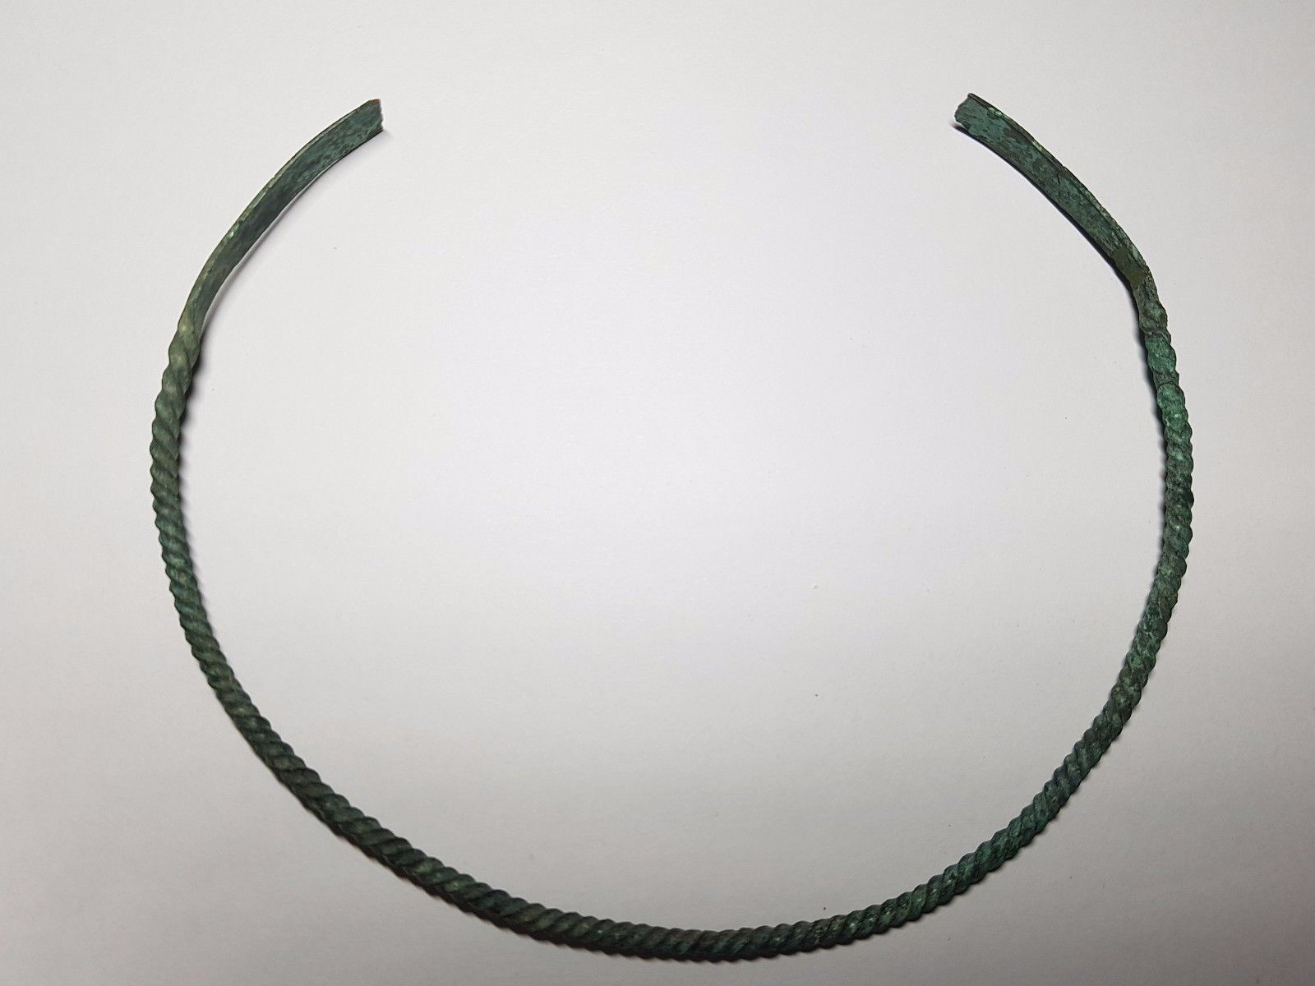

**Case no.:**

**Accession Number:**

**Formal Label:**

**Display Description:**

A penannular bronze torc or neck-ring with an expending twisted body, and scrolled flat-section finials. These torcs were illustrative of the symbolism of the Celtic serpent that was thought to protect the wearer from harm (Roderick and Davidson 1988). An example of such a torc is found on the famous “dying Gaul” or the “dying Galatian,” a Hellenistic sculpture dated to 230-220 BCE and preserved in a marble Roman copy now in the Capitoline Museums, Rome.

**LC Classification:**

**Date or Time Horizon:** 250 BCE

**Geographical Area: Anatolia**

**Map:**

**GPS coordinates:**

**Cultural Affiliation:** Galatia

**Medium:** copper

**Dimensions:** Dia 156 mm.

**Weight**: 25 gms

**Condition:**

**Provenance:** Private collection, Cambridgeshire, UK

**Discussion:**

**References:**

 Roderick, Hilda and Ellis Davidson.1988. *Myths and Symbols in Pagan Europe: Early Scandinavian and Celtic Religions.* Manchester, U.K.: Manchester University Press.